**uxcell DC 12V 74RPM 6.4Kg.cm Self-Locking Worm Gear Motor with Encoder and Cable, High Torque Speed Reduction Motor**

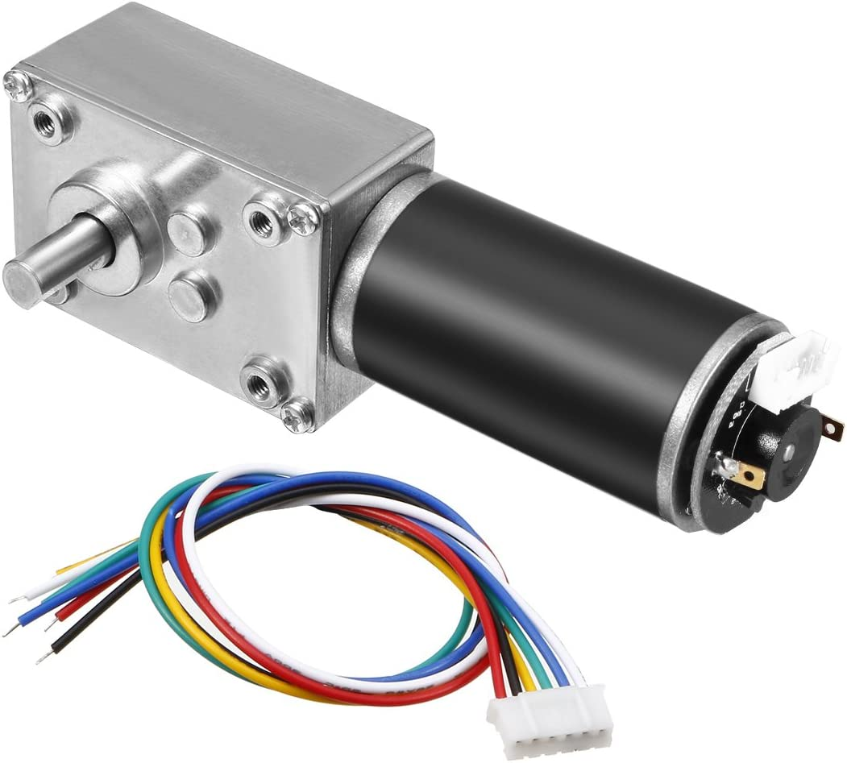**Description**

DC 12V 74RPM 6.4Kg.cm Self-Locking Worm Gear Motor With Encoder And Cable, High Torque Speed Reduction Motor

**Specification:**

Voltage: DC 12V

No-Load Speed: 74rpm

Reduction rate: 1:54

Torque: 6.4Kg.cm

Error: ±10%

Wire Length: 20cm / 7.87inch

Output Shaft Diameter: 8mm / 0.31inch D-type

Output Shaft Length: 15mm / 0.59inch

Total Size(not include shaft):40*36*125mm / 1.57*1.41*4.92inch

**Notice:**

1. The yellow and green wires are the speed signal output line, and they can't be connected any power supply, or it will be burnt.

2. Positive and negative power supply of encoder do not allow connect wrong;voltage is 3.3-5V.

3. Control CW or CCW of motor by changing the positive and negative power supply of encoder (change Red Wire and White Wire connect)

**Wirings:**

Red Wire - positive power supply of motor(+)

White Wire - negative power supply of motor(-)

Black Wire - negative power supply of encoder(-) (positive and negative power supply of encoder do not allow connect wrong;voltage is3.3-5V)

Blue Wire - positive power supply of encoder(+) (positive and negative power supply of encoder do not allow connect wrong;voltage is 3.3-5V)

Yellow Wire - signal feedback (11 signals per motor turns a circle)

Green Wire - signal feedback (11 signals per motor turns a circle)

**Package Include:**

1 x motor , 1 x 6-Wire Connector